Microsoft Expression Web #1: Getting Started
By completing this lesson, you will be able to do the following:
- Launch and exit Expression Web
- Identify Task Panes and Toolbars
- Identify and view folder lists
- Create a one-page website
- Access the Expression Web help facility
When you first open Expression Web, the program window opens displaying a blank new page menus, a toolbar, task panes and a status bar. The title bar across the top of the screen contains the program and Web site names with the menu bar directly below it and the Common toolbar below the menu bar. The task panes provide options that relate to the current task. The View tabs which offer access to Design, Split and Code modes occupy a small area at the bottom of the screen. These tabs allow you to view pages from different perspectives; the program's default is Design view.
Start Expression Web Using the Start Menu
- Click the Start button on the
taskbar.
- Point to All Programs.
- Click Microsoft Expression.
- Click Microsoft Expression Web. A blank new page appearse ready for you to enter text.
- Use the following words to label the following parts in the screen mock-up which appears below: active web page, common toolbar, task panes, status bar, editing window, editing window, view buttons and folder list.

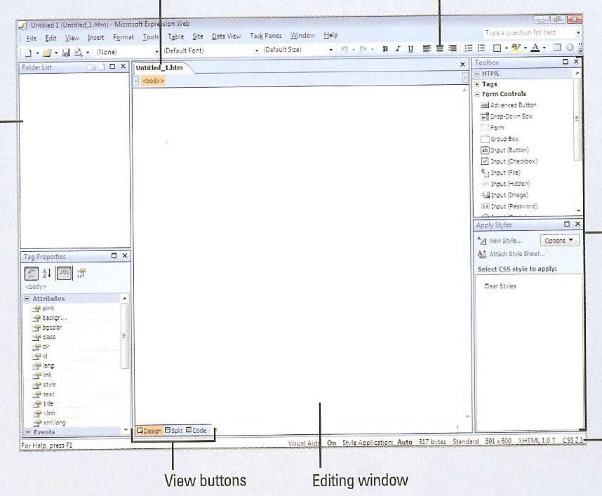
Working with Toolbars
Toolbars contain buttons you can click to carry out commands you use frequently. Expression Web provides 11 different toolbars for you to use to execute commands. The Common toolbar appears by default under the menu bar and provides the most commonly used commands. You can quickly show or hide the toolbars you need or are no longer using to customize the way you use Expression Web.
- To show or hide a toolbar, Click the View menu and then point to Toolbars.
- Click the unchecked toolbar you want to display or the checked toolbar you want to hide. lf a toolbar is undocked, you can click the Close button to hide the toolbar.
Using Task Panes
When you start Expression Web, four task panes appear by default: Folder List, Tag Properties, Apply Styles, and Toolbox. You can open any of the 18 task panes in the Expression Web window using the Task Panes menu. The task panes are grouped together in a window based on the sections displayed on the Task Panes menu and appear as tabs in the same task pane. Each task pane displays various options that relate to the title. When you open and close task panes or move them around, Expression Web saves the arrangement and uses it as the default the next time you start the program.
- To open a task pane, click the Task Panes menu and then click the closed task pane
you want to open. The task panes with a check mark next to the name are already open.
- To close a task pane, click the Task Panes menu and then click the open task pane you
want to close.
Viewing the Folder List
The interface in Expression Web is much different than that found in Microsoft Office 2002. Take for example the folder list. It is a useful task pane for managing files and folders. When you create or open a Web site, a tab for the site appears at the top of the Editing window with the site's files listed in the window and adjacent Folder List. The Folder List displays the file hierarchy of all the folders and files in your Web site and the Editing window displays Web site files and folders or individual Web pages. This arrangement enables you to view the file hierarchy of your Web site and the contents of a folder simultaneously making it easy to manage files and folders. You can click on the “+” and “-“ icons next to each folder to expand and contract parts of the folder hierarchy.
- Open the Web site in which you want to view. lf necessary, click the View menu
and then click Folder List to display the Folder List.
- Click on the “+” sign next to a folder and in the space below, record what happened:

- Do the same with a “-“

Creating a Simple Web Page
When you start Expression Web, a blank page appears. By default, this page is titled . You can create new Web pages and sites in several ways: using the New Document button on the Common toolbar or the New command on the File menu. Expression Web numbers new pages consecutively. The insertion point (blinking cursor bar) appears in the page where text will appear when you type. As you type, text moves or wraps to a new line when the previous one is full. You can move the insertion point anywhere within the page to insert new text and edit existing text. You can copy or move items from one place to another within a Web page or from other programs.
- To create a Web Page, click the New Document button on the Common toolbar. The default page type is HTML.
- Click where you want to insert text or select the text you want to edit. Type “My First Web Page” in the top of the editing window.
Saving a Web Page
Saving your work frequently (about every 10 minutes) ensures you don’t lose work. This is especially important if you work on large scale web design projects.

- Choose the “Save As” command from the file menu.
- Browse out to your network home directory (H:).
- Create a new folder titled “My Website”.
- In the “Filename” field, type “My First Web Page” and click <OK>.
- Exit Expression Web.

Opening an Existing Web Page

- Launch Expression Web.
- Select the “Open” command from the file menu.
- Browse out to your network home directory (H:).
- Double-click on the “My Website” folder you created in the previous section.
- Double-click the file “My First Web Page” you created and click <OK>. The page is now open with the interface configured as it was after you exited the program.
- After you finish work on a web page, you can close by choosing the “Close” command on the file menu.

Getting Help While You Work

Even the most experienced web designers reach a point where they don’t know how to perform a task. Perhaps, the problem may be as not knowing where a specific command is located. Other times, problems can be more complex such as not knowing how to perform a particular task. Regardless of the problem, the help modules allow you to view solutions to wide arrays of problems which most every aspiring web designer has faced at one time or another.

- Click the Help menu and select the “Microsoft Expression Web Help” command. The help dialog appears.
- Click the “Web Pages topic.” Click the “Web Pages” subtopic. Read the content which follows. In the space below, summarize the main idea of the topic:

- Click the <BACK> button twice. Click the “Websites” topic this time and then click “Websites” in the subtopic menu which follows.
- In the space below, explain how websites differ from web pages:

